**Objective:** Be able to create a Unit Test class for the given **ContributionUtility** class.

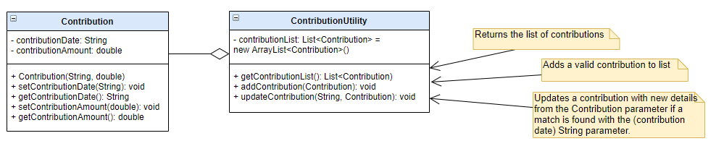

**Sample Junit Execution:**

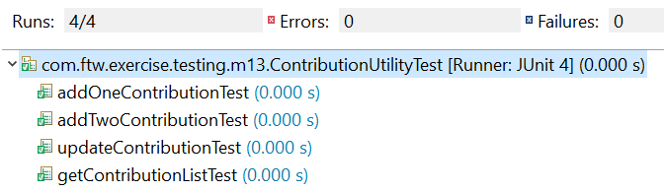

Use ContributionUtility class below



**Instructions:**

1. Create a new simple Maven project with the following details:

**Group-id:** com.sot.exercise

**Artifact-id:** sot-unit-testing

**Package Name:** com.sot.exercise.junit

1. Configure your newly created project to be able to utilize the **junit** dependency.
2. Create the **Contribution** and **ContributionUtility** classes based on the UML class diagram.
3. Create **ContributionUtilityTest** class in the appropriate source folder with the following scenarios:
   1. getContributionListEmptyTest() – checks if the list is not null.
   2. addOneContributionTest() – checks that the utility class can add a Contribution object and store it in the list
   3. addTwoContributionTest() – checks that the utility class can add and store multiple Contribution objects.
   4. updateContributionTest() – checks that the utility class can update Contribution details.

**Note:** Add appropriate setup() and tearDown() methods.